`
Data and data structure, Development of data set using Excel and Tableau

Contents
No table of contents entries found.

BY MANUEL MUNTU
April 2023

ASSIGNMENT 1 DATA VISUALIZATION

HYSTORY

Hard disks, large capacity mass storage, were invented a long time ago. The invention of this hard disk made it possible to use computers to collect, classify and store large quantities of information in a more flexible and efficient way than the previous medium: magnetic tape.

The term database appeared in the 20th century to designate a collection of information shared by different users of a military information system.

The first hierarchical databases appeared in the early 1960s. Information was split into two levels of hierarchy: one level contained information that is identical across multiple records in the database. The breakdown was then extended to take the form of a tree diagram.
In 1969, Charles Backman created the network data model within the CODASYL consortium for computer applications for which the hierarchical model is not suitable and he received the Turing award in 1973 for his "outstanding contributions to database technology."

In 1968, Dick Pick created Pick, an operating system containing a “multivalued” database management system.

In 1970, Edgar F. Codd noted in his mathematical thesis on relational algebra that a set of entities is comparable to a family defining a relation in mathematics and that joins are Cartesian products. This thesis is at the origin of relational databases.

The entity-relationship model was also invented and is intended to clarify the organization of data in relational databases.

In 1990, the LEADERS legal database, with monthly updates on clients' computers, initially on diskettes was launched in Belgium.

In the relational model, the relationship designates the set of information in a table, while the association, in the entity-association model, designates the logical link that exists between two tables containing related information.

The first databases were modeled on the presentation of punched cards: divided into rows and columns of fixed width. Such a distribution makes it difficult to store programming objects; in particular, they do not allow inheritance between entities, characteristic of object-oriented programming.

Appeared in the 1990s, object-relational databases use a relational data model while allowing the storage of objects. In these databases, the inheritance associations of objects are added to the associations between the entities of the relational model.

POLICIES AND PROCEDURES.
Policies and procedures must be considered when working with data. Following are some rules to consider:
The controller and the purposes of collecting this data (purposes); the legal basis for the data processing; the compulsory or optional nature of the collection of data for the management of the request and the reminder of the categories of data processed; the source of the data (when data other than that provided via the online service is used to process your request); the categories of data subjects.
the recipients of the data (only the CNIL in principle, unless specified when transmission to a third party is necessary); the data retention period; security measures (general description); the possible existence of data transfers outside from its sources (for example: Countries, cities etc..).
As a data analyst all personal data collected must be protected, not to transmit them to third parties without the user having been informed and to respect the purposes for which these data were collected.
Being in mind that the collection of data without providing the necessary information about the subsequent processing is punishable by law. Thus, a confidentiality policy must be established as soon as the company or the website plans to collect, directly or indirectly, the personal data of its customers or users.
In addition, those that do not comply with the provisions of the GDPR incur sanctions, in particular fines that can go up to 4% of their overall turnover. Also, the organization handling the personal data must inform the data subject in the event of a change in the context of a particular event. Thus, any modification must be notified to the owner of the information, however small.

EXCEL

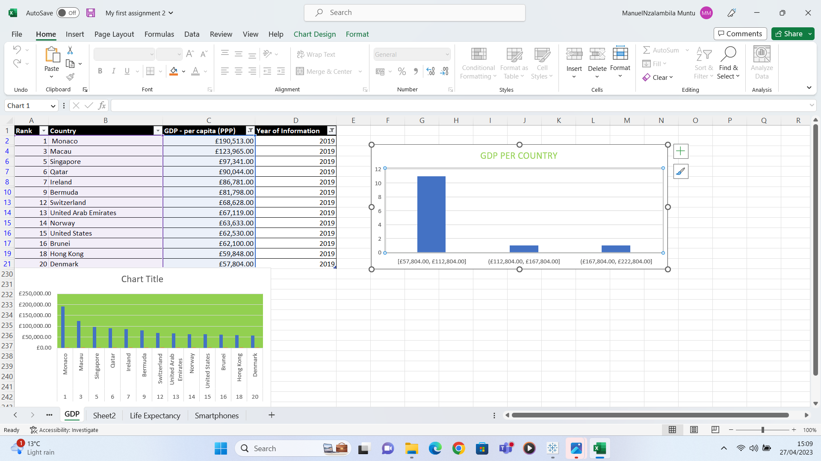
Rank | Country | GDP - per capita (PPP) | Year of Information
1 | Monaco | £190,513.00 | 2019
3 | Macau | £123,965.00 | 2019
5 | Singapore | £97,341.00 | 2019
6 | Qatar | £90,044.00 | 2019
7 | Ireland | £86,781.00 | 2019
9 | Bermuda | £81,798.00 | 2019
12 | Switzerland | £68,628.00 | 2019
13 | United Arab Emirates | £67,119.00 | 2019
14 | Norway | £63,633.00 | 2019
15 | United States | £62,530.00 | 2019
16 | Brunei | £62,100.00 | 2019
18 | Hong Kong | £59,848.00 | 2019
20 | Denmark | £57,804.00 | 2019

TABLEAU

